create database food_sales;

use food_sales;

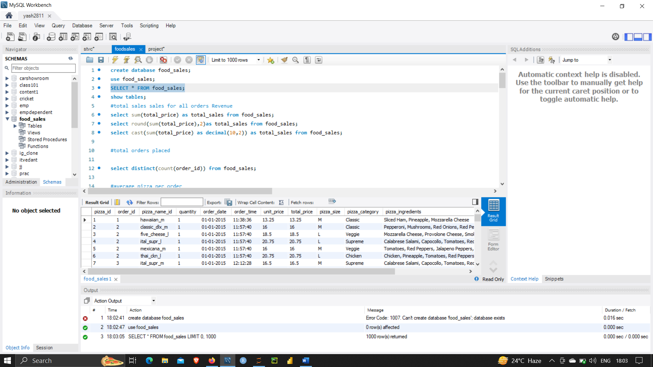

**#TOTAL SALES SALES FOR ALL ORDERS REVENUE**

select sum(total_price) as total_sales from food_sales;

select round(sum(total_price),2)as total_sales from food_sales;

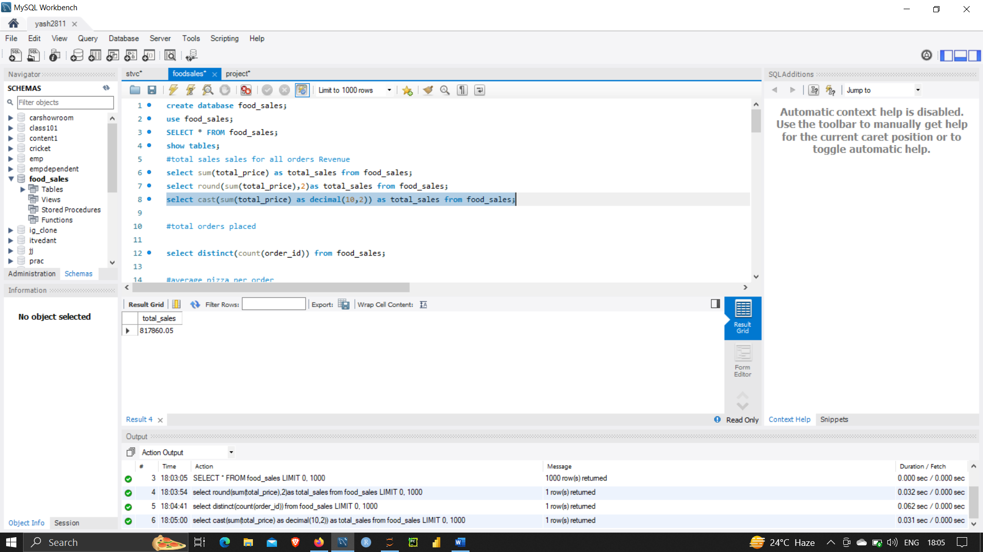

**#TOTAL ORDERS PLACED**

select distinct(count(order_id)) from food_sales;

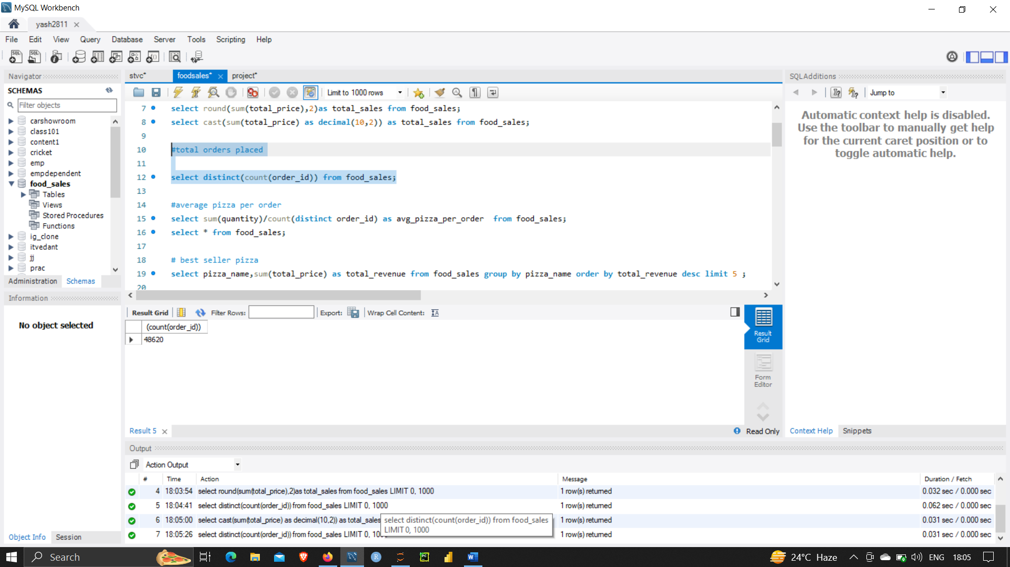

**#AVERAGE PIZZA PER ORDER**

select sum(quantity)/count(distinct order_id) as avg_pizza_per_order from food_sales;

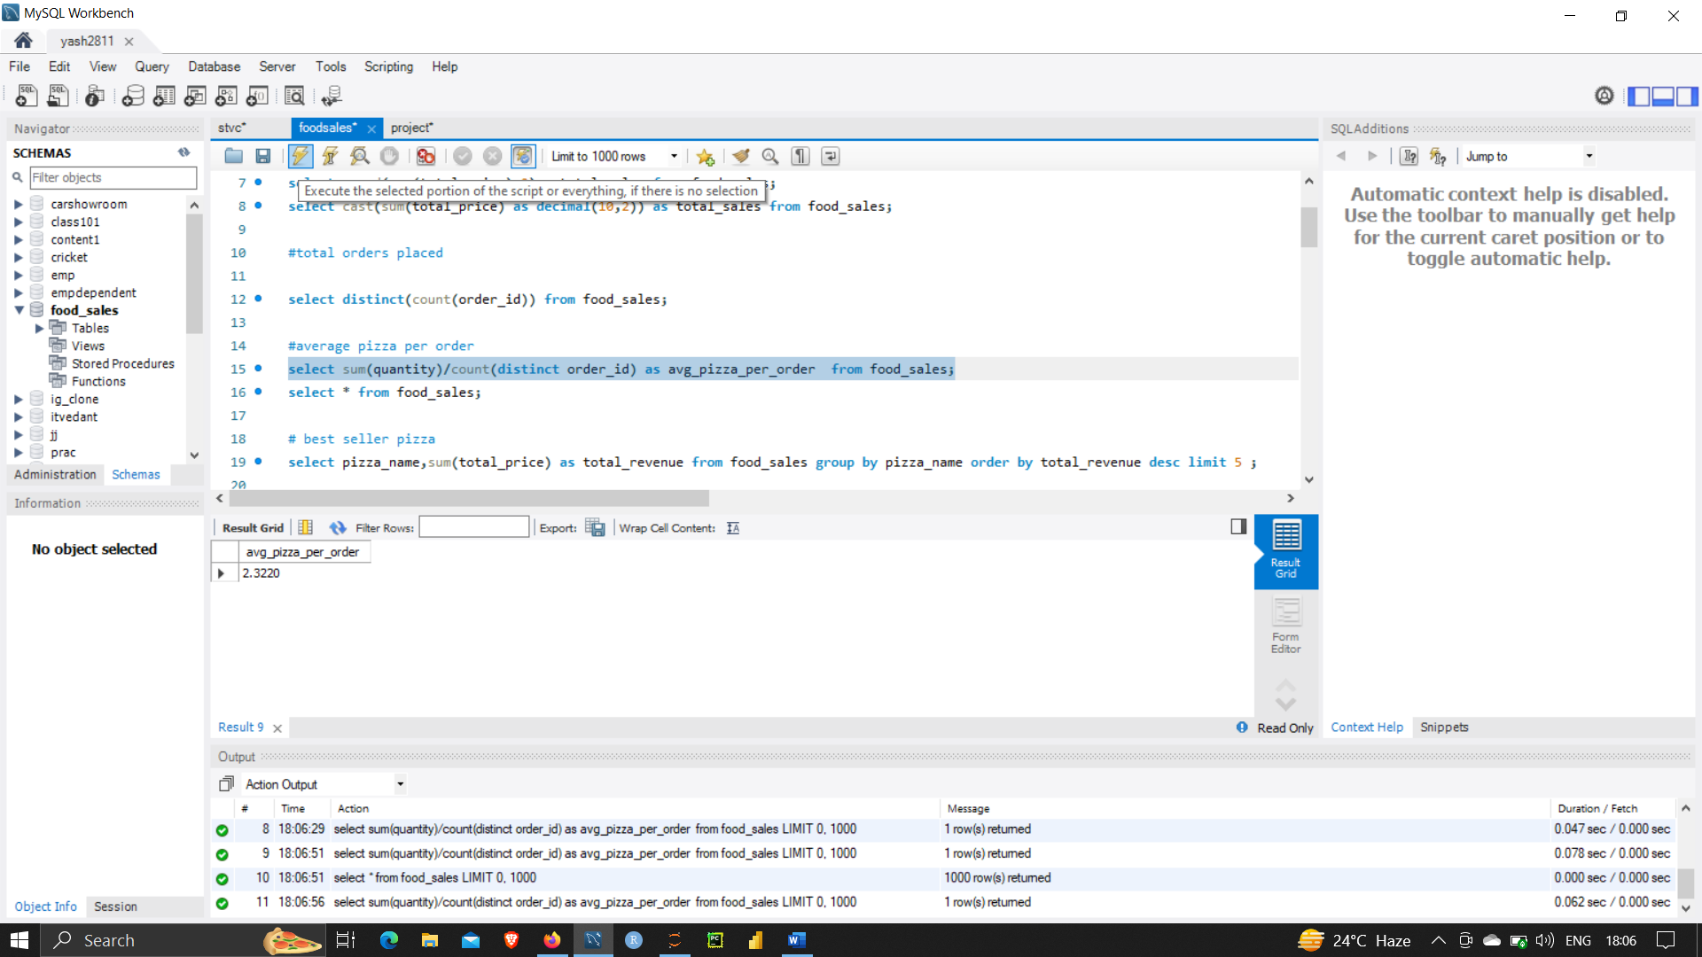

**# BEST SELLER PIZZA**

select pizza_name,sum(total_price) as total_revenue from food_sales group by pizza_name order by total_revenue desc limit 5 ;

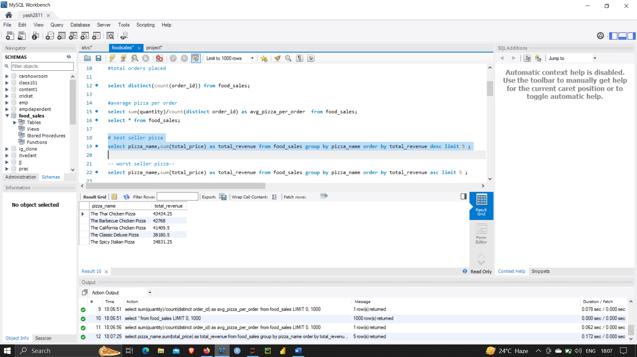

**#WORST SELLER PIZZA**

select pizza_name,sum(total_price) as total_revenue from food_sales group by pizza_name order by total_revenue asc limit 5 ;

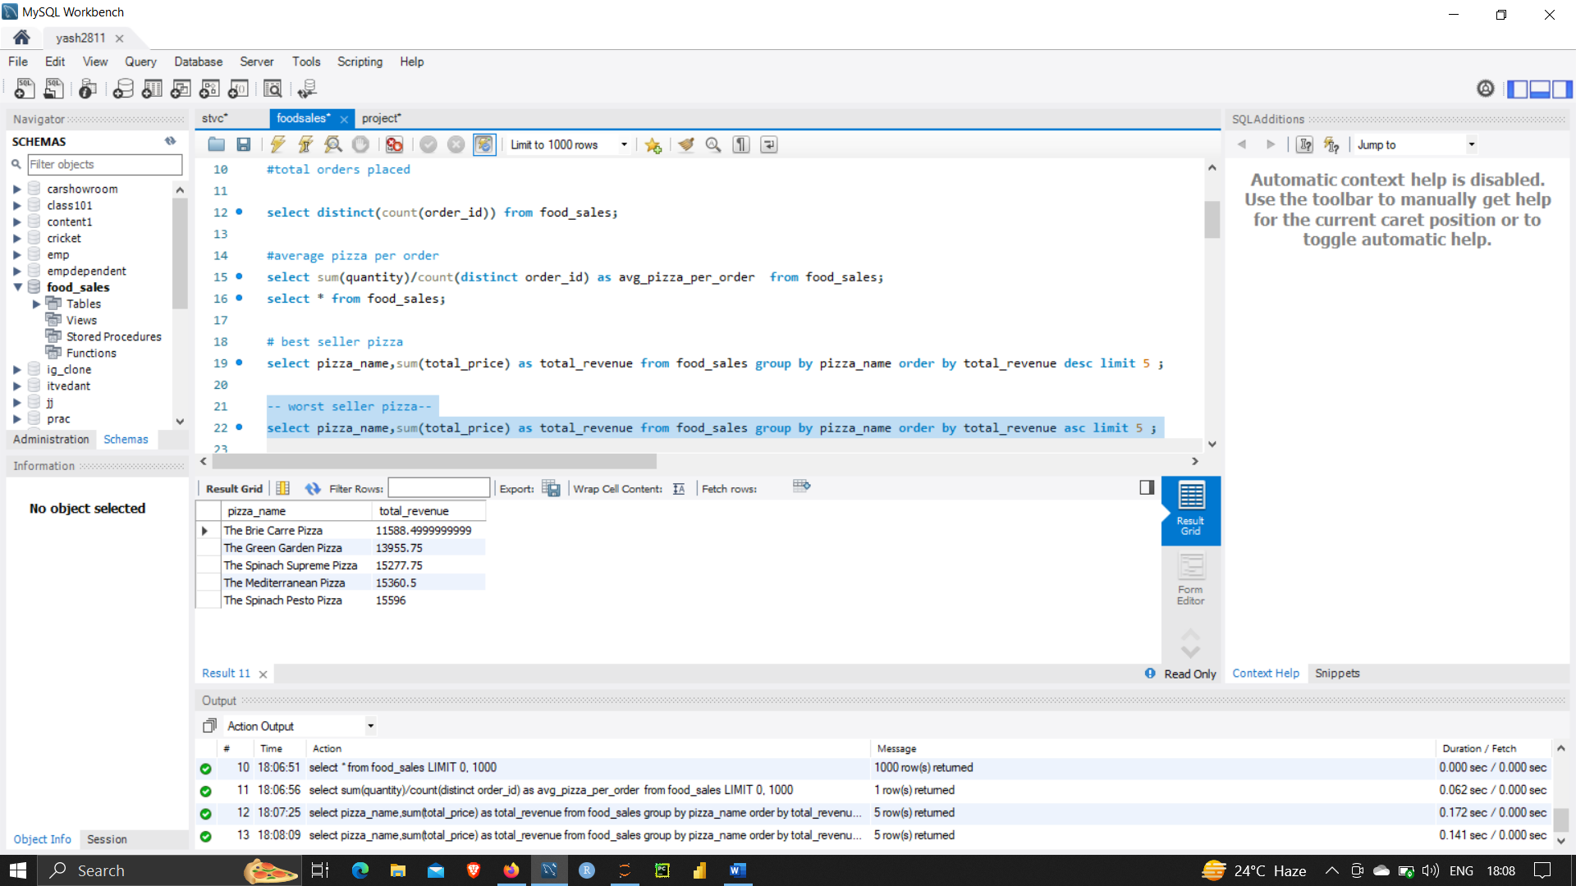

**#MONTHLY TREND OF ORDER**

-- alter table food_sales modify column order_date date;

select date_format(str_to_date(order_date,'%d-%m-%Y'),'%M') as formatted_month,

count(distinct order_id) as total_order from food_sales group by formatted_month order by total_order desc;

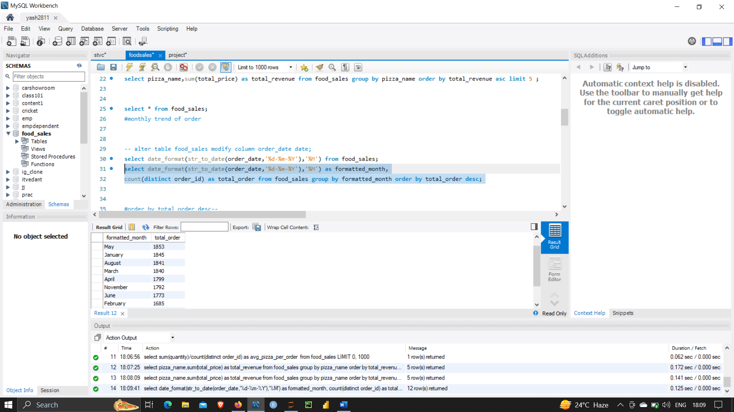

**#THE BELOW QUERY FETCHES THE DAY WISE SALES FOR PIZZA ORDER**

select date_format(str_to_date(order_date,'%d-%m-%Y'),'%a') as formatted_day ,

count(distinct order_id) as total_order from food_sales group by formatted_day order by total_order desc ;

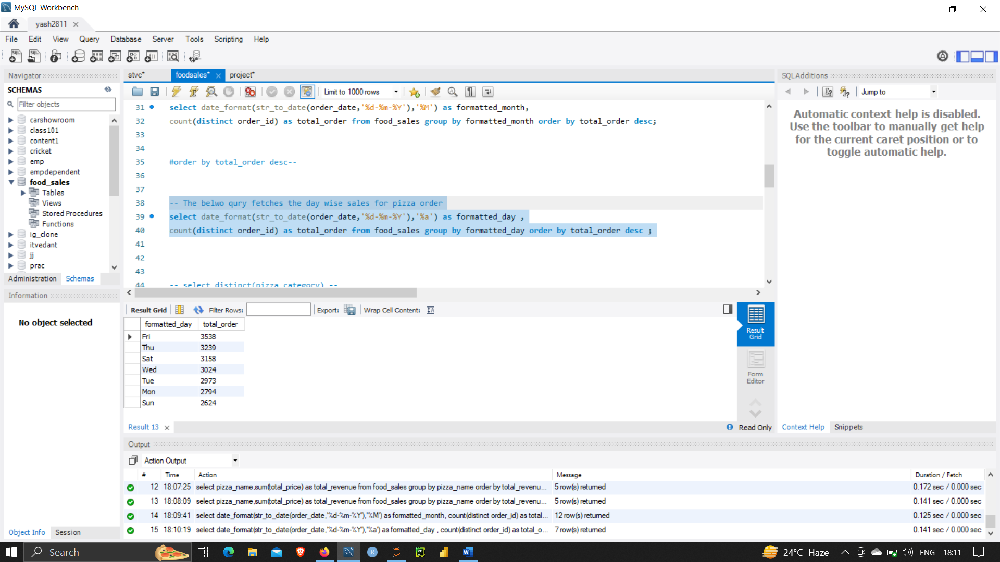

**#TOTAL SALES BY PERCENTAGE**

select pizza_category,sum(total_price) as total_sales, (sum(total_price)*100.0/(select sum(total_price) from food_sales)) as percentage_of_total_sales from food_sales group by pizza_category;

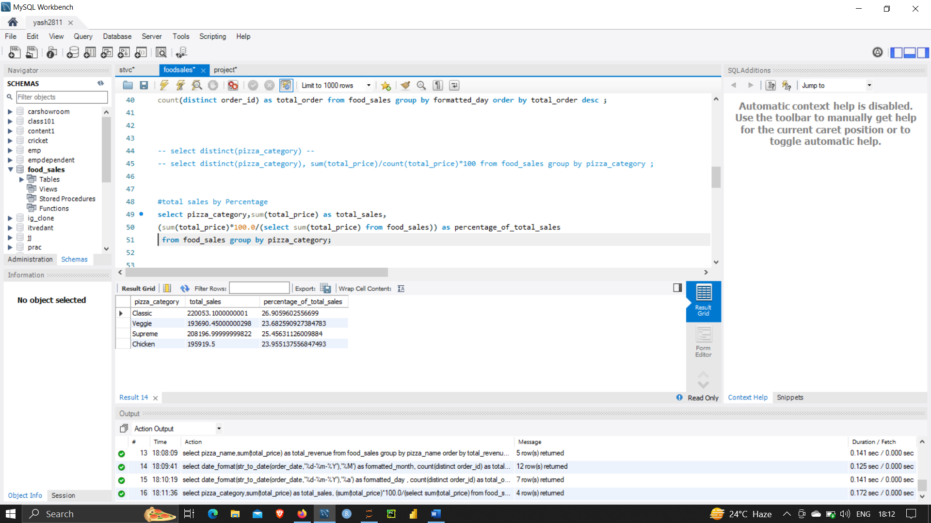

**#QUATERILY SALES**

select quarter((str_to_date(order_date,'%d-%m-%Y'))) as pp ,

round(sum(total_price),2) as total_order from food_sales group by pp;

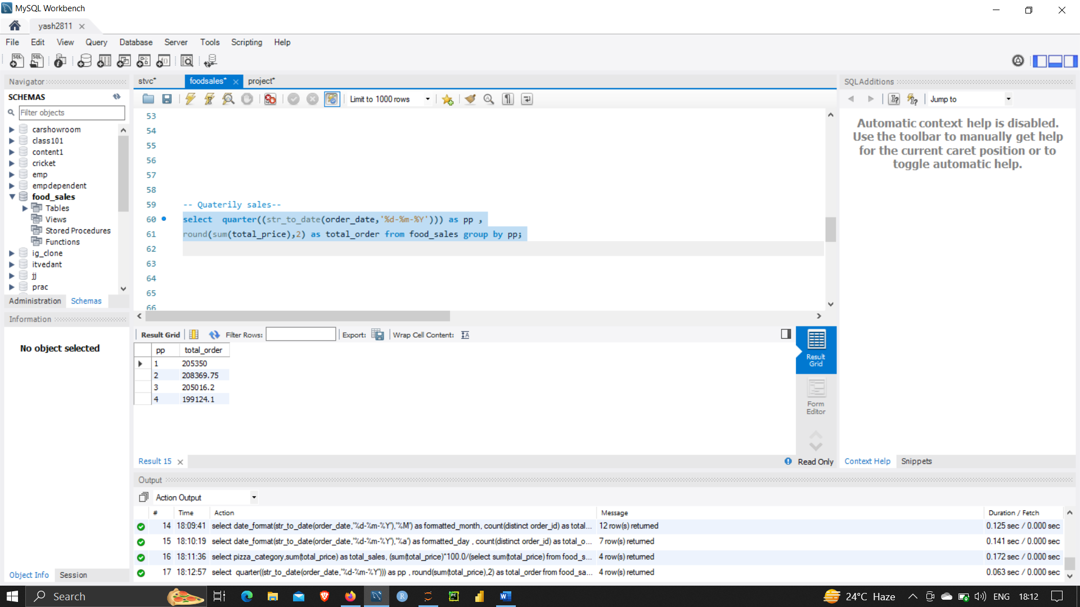

**# PERCENTAGE OF SALES BY PIZZA SIZE**

select pizza_size , sum(total_price) from food_sales group by pizza_size ;

select pizza_size,sum(total_price) as total_sales,

(sum(total_price)*100.0/(select sum(total_price) from food_sales)) as percentage_of_total_sales

from food_sales group by pizza_size;

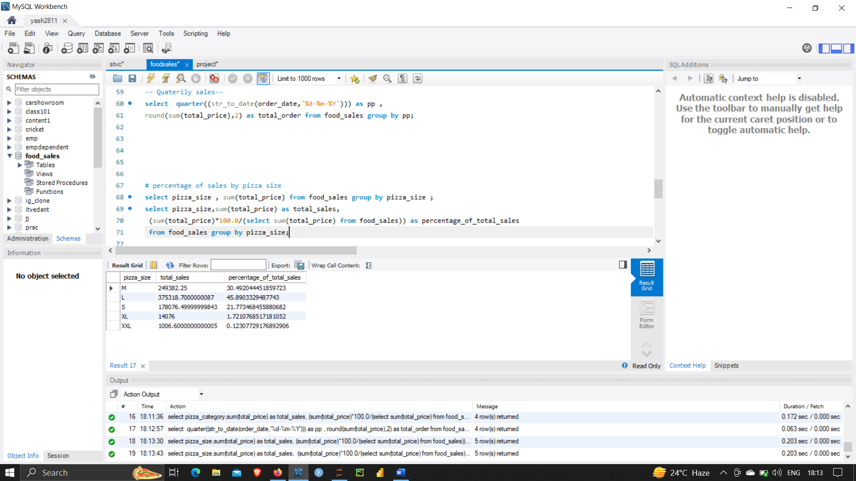

#day wise order of pizza

select date_format(str_to_date(order_date,'%d-%m-%Y'),'%a') as formatted_day ,

sum(total_price) as total_order from food_sales group by formatted_day order by total_order desc;

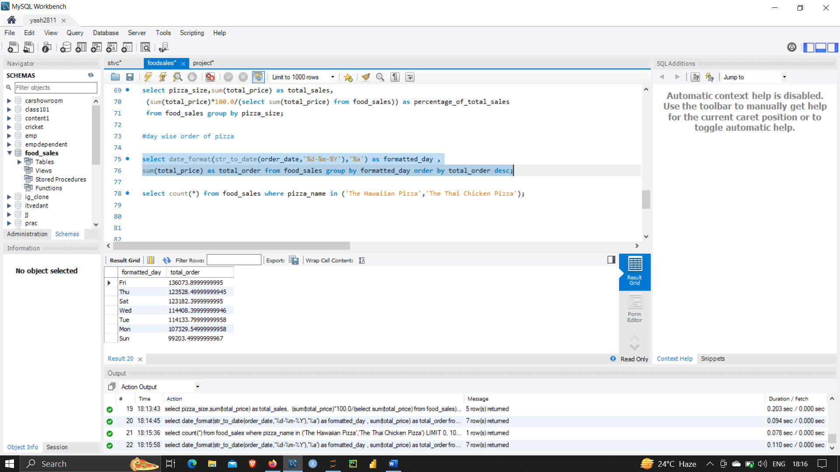

#Weekday and weekend sales;

select

case

when dayofweek(str_to_date(order_date,'%d-%m-%y')) in (1,7) then 'weekend'

else 'weekday'

end as day_category,

sum(total_price) as total_sales

from food_sales group by day_category;

